Scientific & Industrial Equipments

BY –Deepen Ramesh Mandve
T.Y.Bsc (COMPUTER SCIENCE)

“Scientific & Indutrial Equipments”
DESIGNED & DEVELOPED BY
Mr. DEEPEN RAMESH MANDVE(18)
UNDER THE GUIDANCE OF
PROF. MRS. GRETA DABRE
THIRD YEAR BACHELOR OF SCIENCE
(COMPUTER SCIENCE) SEM- V
2021-2022
UNIVERSITY OF MUMBAI


A.V. COLLEGE OF ARTS , K.M. COLLEGE
OF COMMERCE, E.S.A. COLLEGE OF SCIENCE
VASAI ROAD(WEST) DIST. PALGHAR-401202
MAHARASHTRA

ACKNOWLEDGMENT

I would like to acknowledge my sincere thanks
Towards our project guide
Head of Computer Science Department
Mrs. Srimathi Narayanan,
for their valuable guidance and suggestions and providing me an
opportunity to do the project work in the college lab and
which made me complete the project successfully.

I am also thankful to
Mrs. GRETA DABRE
for providing such nice guidance in form of comments and corrections.
I am thankful to and fortunate enough to get constant
encouragement, support and guidance from all teaching
staff of Computer Science which helped us in
Successfully completing our project work. Also, I would
like to extend our sincere esteems to all staffs in
laboratory for their timely support.

DEEPEN RAMESH MANDVE
T.Y.Bsc (COMPUTER SCIENCE)

DECLARATION

I hereby declare that I Deepen Mandve.
Of T.Y.BSc Computer Science
Roll Number: 18
has Successfully completed Project.

I declare that I have carried out the project on my own and
the project is found to be Successfully Working.
All the Documents and the reports submitted
are true to best of my Knowledge.

DEEPEN MANDVE
T.Y.BSc Computer Science

INDEX PAGE
Sr. No | Contents | Page No.
1. | Introduction (Synopsis) | 6
2. | Limitation of Current System | 8
3. | Advantage of Proposed System | 9
4. | Feasibility Study  - Technical Feasibility  - Economical Feasibility  - Organizational Feasibility  - Cultural Feasibility | 10
5. | 1. Requirement Specification  (Software and Hardware Req.) | 11
6. | System Design Details  - Event Table  - Entity Relationship Diagram  - Class Diagram  - Use Case Diagram  - Activity Diagram  - Sequence Diagram  - Component Diagram  - Deployment Diagram  - Database Design | 12
7. | System Implementation (CODE) | 26
8. | Result  (Screenshot of the Web Page.) | 54
9. | Future Scope and conclusion | 61
10. | Reference | 62

GANTT CHART
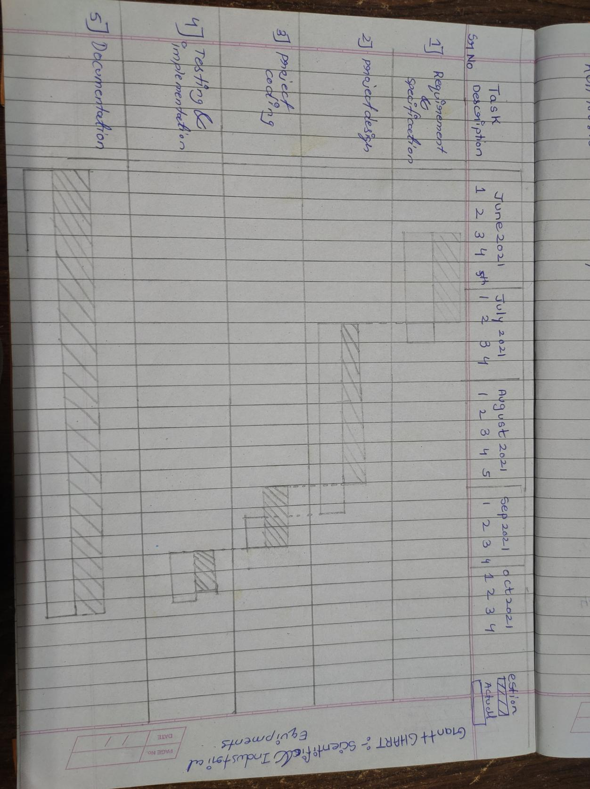

INTRODUCTION

This project is aimed at developing a website that depicts online shopping of scientific and industrial equipments using this software companies can improve their efficiency of their services this website involves all the features of online shopping firstly customer can browse and select product of his or her interest. The selected items may be collected in a Shopping Cart then the item in the Shopping Cart will be presented as an order. At that time, more information will be needed to complete the order. Usually, the customer will be asked to fill or select billing address and payment information after that a notification will be sent to customer as soon as order is placed .
There are three roles available:-
1) visitor can view available products
2) user can view and purchase the product
3) an Admin has some extra advantages than user. Admin can add , edit product information and remove products.
4) Admin can ship order to user based on order sending mail confirmation.

LIMITATION OF CURRENT SYSTEM

The current system for shopping is to visit
the shop manually and search for available
product and choose from it. Sometimes
products are not available at the shop and
have to search for products in the other
shop which makes difficult for user or
customer to search product. New
customers don't it know the exact price of
item and shopkeeper take advantage of
this and sell product at high price.

Advantage of Proposed System

Advantages of my project:
- Faster buying process customer can spend less time for shopping for what they want can easily browse through many items at a time and by what they like.

- Flexibility for customers:-customers can order product and services anytime. The result is that seller can offer his item at any place, anytime. There is no limit to see a product.

- No reach limitations:- A seller with physical store may only reach a certain number of buyers

- More Payment mode:- buyers can pay their orders using UPI, cash on delivery,card on delivery.

- If user dislikes any product he/she can return it.

FEASIBILITY STUDY

Feasibility of a new system means ensuring that the new system,which we are going to implement, is efficient and affordable. There are various types of feasibility to be determined they are

- Technical Feasibility:-Technologies that are used to develop this budget analysis system are PHP for creating effective looking interfaces. I will use PHP language that will be used to perform all the logical operations for better functionality. I will also use MYSQL for storing all the orders products user details etc.
- Economically Feasibility:- Development of this project system is highly economically feasible.The only thing to be done is making an environment with an effective supervision. It is cost effective in the sense that the person need not to spend money to go to market. The system is also time effective because it save time to search for the product.
- Operational Feasibilty :-The system working is quite easy to use and learn due to its simple but attractive interface. User requires no special training for operating the system.technical performance include issues such as determining wheather the system can provide the right information for the given product and changes that user make on system.
- Cultural Feasibility:-There are no restrictions made, everyone can access this website almost every being can access this. The only problem to the user will be the interface which is only in English, no other language option is available. Every user can login with his/her assigned username and password and can perform the basic activities.

REQUIREMENT SPECIFICATION

Software Requirements:
- Visual Studio Code(PHP Intellisence).
- Xampp server.
- Google Chrome Browser.
- Bootstrap.

Hardware Requirements:
- Intel core i3 @2GHz.
- 4 GB RAM.
- 1 TB Hardisk.
- Apache HTTP Server.
- MySQL.
PHP7.

SYSTEM DESIGN DETAILS

- Event Table

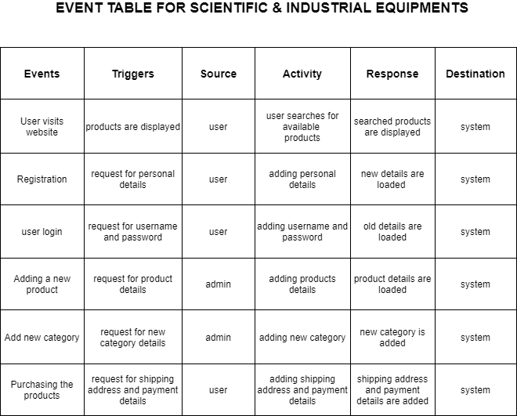

B] ER DIAGRAM
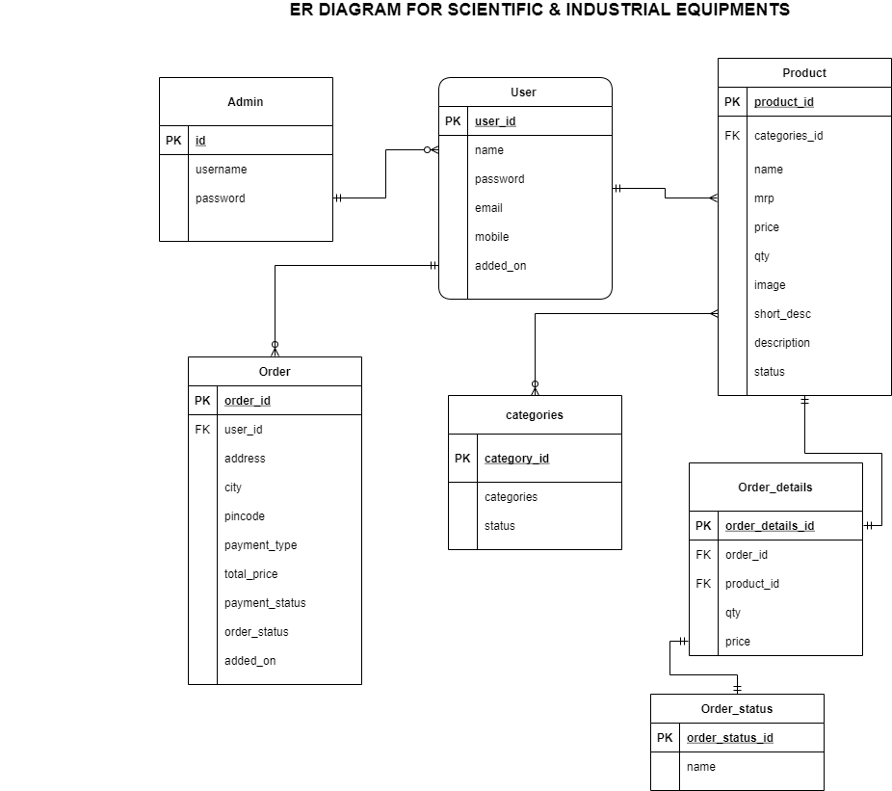

- CLASS DIAGRAM

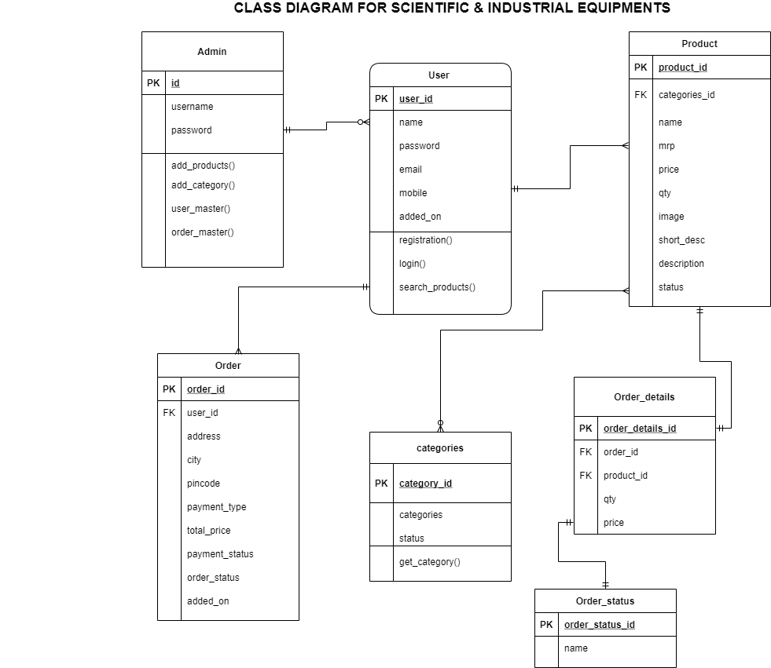

- ACTIVITY DIAGRAM
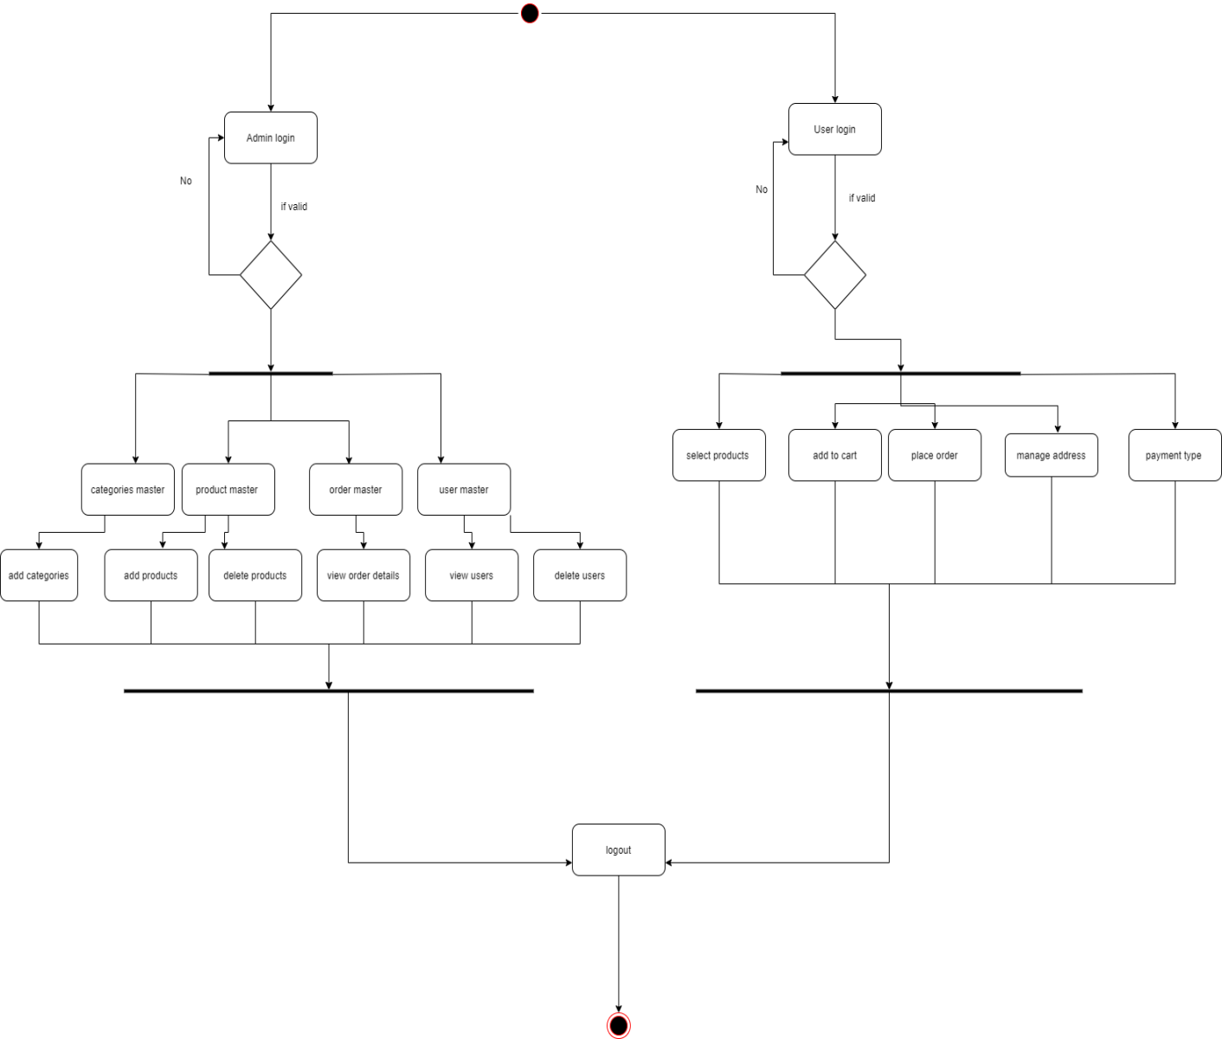

- USE CASE DIAGRAM

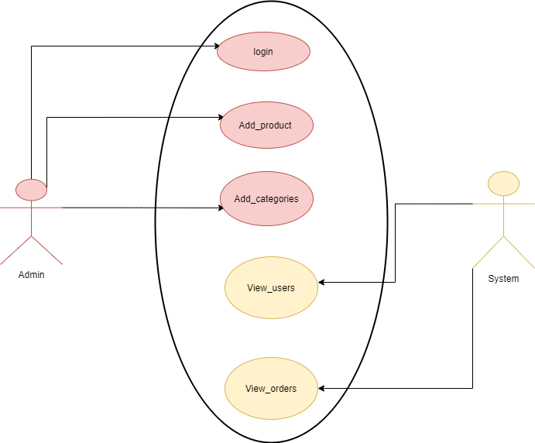

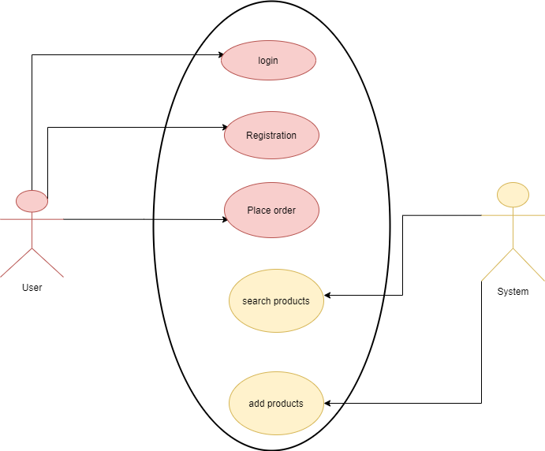

- Sequence diagram:

USER:

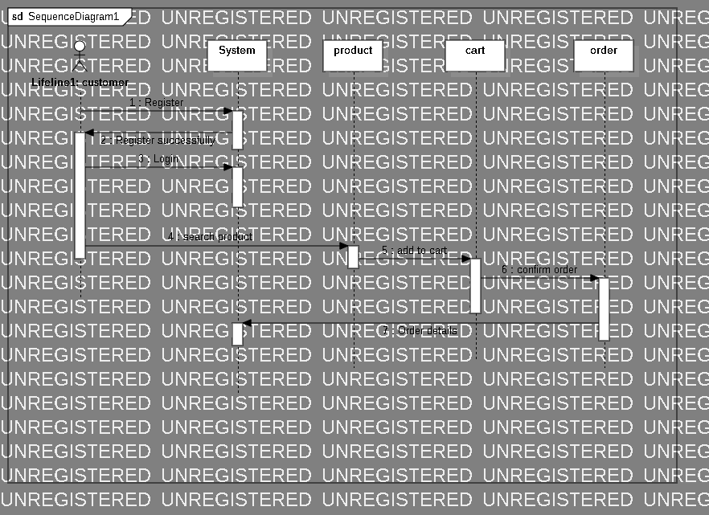

ADMIN:
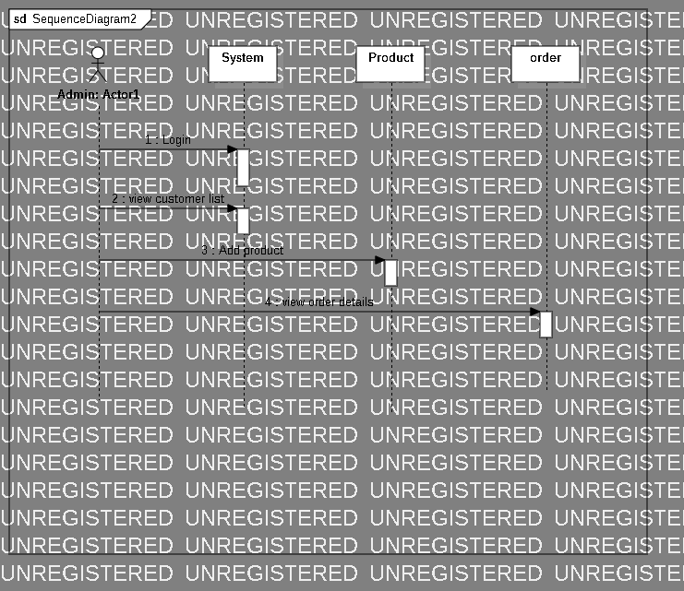

- COMPONENT DIAGRAM

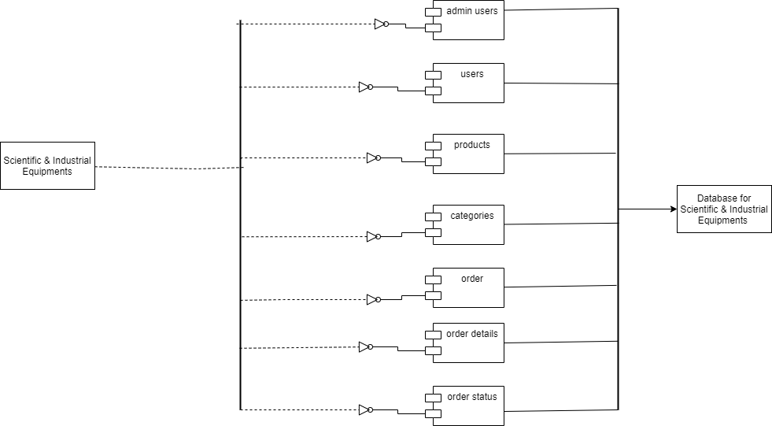

- Deployment diagram:

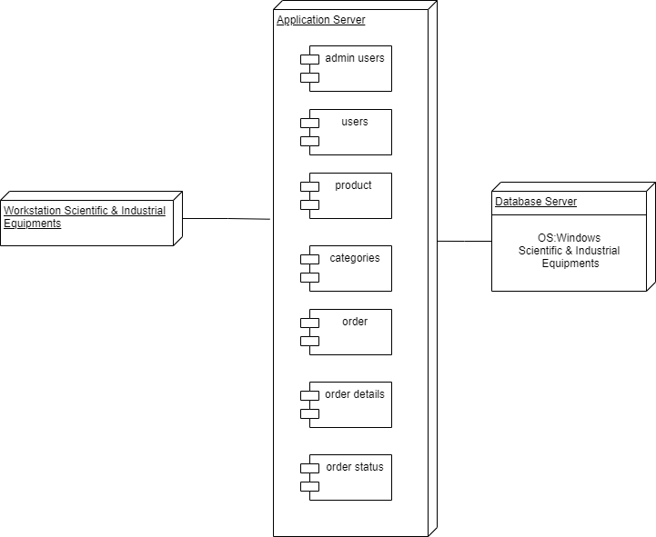

- Database design
ADMIN
Field | Datatype | Size | Constraint
id | Int | 11 | Primary key
Username | varchar | 255 | Not NULL
Password | varchar | 255 | Not Null

USERS
Field | Datatype | Size | Constraint
id | Int | 11 | Primary key
name | varchar | 255 | Not NULL
password | varchar | 255 | Not Null
email | varchar | 255 | Not NULL
mobile | int | 15 | Not Null
added_on | datetime | - | Not Null

Product
Field | Datatype | Size | Constraint
Product_id | int | 11 | Primary key
Categories_id | int | 11 | FK
name | varchar | 255 | Not Null
mrp | flaot | 255 | Not NULL
price | float | 255 | Not Null
qty | int | 15 | Not Null
image | varchar | 255 | Not Null
Short_desc | varchar | 2000 | Not NULL
description | text | 2000 | Not Null
status | tinyint | 4 | Not Null

Categories
Field | Datatype | Size | Constraint
Category_id | int | 11 | Primary key
categories | varchar | 255 | Not Null
status | tinyint | 4 | Not NULL

Order

Field | Datatype | Size | Constraint
Order_id | int | 11 | Primary key
User_id | int | 11 | FK
address | varchar | 250 | Not NULL
city | varchar | 50 | Not NULL
pincode | int | 11 | Not Null
Payment_type | varchar | 20 | Not Null
Total_price | float | 255 | Not Null
Payment_status | varchar | 20 | Not Null
Order_status | int | 11 | Not Null
Added_on | datetime |  | Not Null

Order details
Field | Datatype | Size | Constraint
Order_details_id | int | 11 | Primary key
Order_id | int | 11 | FK
Product_id | int | 11 | FK
qty | int | 11 | Not Null
price | float |  | Not Null

Order status
Field | Datatype | Size | Constraint
Order_status_id | int | 11 | Primary key
name | Varchar | 25 | Not Null

System implementation
Categories.php
<?php
require('top.inc.php');

if(isset($_GET['type']) && $_GET['type']!=''){
$type=get_safe_value($con,$_GET['type']);
if($type=='status'){
$operation=get_safe_value($con,$_GET['operation']);
$id=get_safe_value($con,$_GET['id']);
if($operation=='active'){
$status='1';
}else{
$status='0';
}
$update_status_sql="update categories set status='$status' where id='$id'";
mysqli_query($con,$update_status_sql);
}

if($type=='delete'){
$id=get_safe_value($con,$_GET['id']);
$delete_sql="delete from categories where id='$id'";
mysqli_query($con,$delete_sql);
}
}

$sql="select * from categories order by categories asc";
$res=mysqli_query($con,$sql);
?>
<div class="content pb-0">
<div class="orders">
<div class="row">
<div class="col-xl-12">
<div class="card">
<div class="card-body">
<h4 class="box-title">Categories </h4>
<h4 class="box-link"><a href="manage_categories.php">Add Categories</a> </h4>
</div>
<div class="card-body--">
<div class="table-stats order-table ov-h">
<table class="table ">
<thead>
<tr>
<th class="serial">#</th>
<th>ID</th>
<th>Categories</th>
<th></th>
</tr>
</thead>
<tbody>
<?php
$i=1;
while($row=mysqli_fetch_assoc($res)){?>
<tr>
<td class="serial"><?php echo $i?></td>
<td><?php echo $row['id']?></td>
<td><?php echo $row['categories']?></td>
<td>
<?php
if($row['status']==1){
echo "<span class='badge badge-complete'><a href='?type=status&operation=deactive&id=".$row['id']."'>Active</a></span>&nbsp;";
}else{
echo "<span class='badge badge-pending'><a href='?type=status&operation=active&id=".$row['id']."'>Deactive</a></span>&nbsp;";
}
echo "<span class='badge badge-edit'><a href='manage_categories.php?id=".$row['id']."'>Edit</a></span>&nbsp;";

echo "<span class='badge badge-delete'><a href='?type=delete&id=".$row['id']."'>Delete</a></span>";

?>
</td>
</tr>
<?php } ?>
</tbody>
</table>
</div>
</div>
</div>
</div>
</div>
</div>
</div>
<?php
require('footer.inc.php');
?>

Connection.php
<?php
session_start();
$con=mysqli_connect("localhost","root","","ecom");
define('SERVER_PATH',$_SERVER['DOCUMENT_ROOT'].'/php/ecom/');
define('SITE_PATH','http://127.0.0.1/php/ecom/');

define('PRODUCT_IMAGE_SERVER_PATH',SERVER_PATH.'media/product/');
define('PRODUCT_IMAGE_SITE_PATH',SITE_PATH.'media/product/');
?>
Fuction.php
<?php
function pr($arr){
echo '<pre>';
print_r($arr);
}

function prx($arr){
echo '<pre>';
print_r($arr);
die();
}

function get_safe_value($con,$str){
if($str!=''){
$str=trim($str);
return mysqli_real_escape_string($con,$str);
}
}
?>
Index.php
<?php
require('top.inc.php');
?>
<div class="content pb-0">
<div class="orders">
<div class="row">
<div class="col-xl-12">
<div class="card">
<div class="card-body">
<h4 class="box-title">Dashboard </h4>
</div>
</div>
</div>
</div>
</div>
</div>
<?php
require('footer.inc.php');
?>
Login.php
<?php
require('connection.inc.php');
require('functions.inc.php');
$msg='';
if(isset($_POST['submit'])){
$username=get_safe_value($con,$_POST['username']);
$password=get_safe_value($con,$_POST['password']);
$sql="select * from admin_users where username='$username' and password='$password'";
$res=mysqli_query($con,$sql);
$count=mysqli_num_rows($res);
if($count>0){
$_SESSION['ADMIN_LOGIN']='yes';
$_SESSION['ADMIN_USERNAME']=$username;
header('location:categories.php');
die();
}else{
$msg="Please enter correct login details";
}

}
?>
<!doctype html>
<html class="no-js" lang="">
<meta http-equiv="content-type" content="text/html;charset=UTF-8" />
<head>
<meta charset="utf-8">
<meta http-equiv="X-UA-Compatible" content="IE=edge">
<title>Login Page</title>
<meta name="viewport" content="width=device-width, initial-scale=1">
<link rel="stylesheet" href="assets/css/normalize.css">
<link rel="stylesheet" href="assets/css/bootstrap.min.css">
<link rel="stylesheet" href="assets/css/font-awesome.min.css">
<link rel="stylesheet" href="assets/css/themify-icons.css">
<link rel="stylesheet" href="assets/css/pe-icon-7-filled.css">
<link rel="stylesheet" href="assets/css/flag-icon.min.css">
<link rel="stylesheet" href="assets/css/cs-skin-elastic.css">
<link rel="stylesheet" href="assets/css/style.css">
<link href='https://fonts.googleapis.com/css?family=Open+Sans:400,600,700,800' rel='stylesheet' type='text/css'>
</head>
<body class="bg-dark">
<div class="sufee-login d-flex align-content-center flex-wrap">
<div class="container">
<div class="login-content">
<div class="login-form mt-150">
<form method="post">
<div class="form-group">
<label>Username</label>
<input type="text" name="username" class="form-control" placeholder="Username" required>
</div>
<div class="form-group">
<label>Password</label>
<input type="password" name="password" class="form-control" placeholder="Password" required>
</div>
<button type="submit" name="submit" class="btn btn-success btn-flat m-b-30 m-t-30">Sign in</button>
</form>
<div class="field_error"><?php echo $msg?></div>
</div>
</div>
</div>
</div>
<script src="assets/js/vendor/jquery-2.1.4.min.js" type="text/javascript"></script>
<script src="assets/js/popper.min.js" type="text/javascript"></script>
<script src="assets/js/plugins.js" type="text/javascript"></script>
<script src="assets/js/main.js" type="text/javascript"></script>
</body>
</html>

Manage_categories.php
<?php
require('top.inc.php');
$categories='';
$msg='';
if(isset($_GET['id']) && $_GET['id']!=''){
$id=get_safe_value($con,$_GET['id']);
$res=mysqli_query($con,"select * from categories where id='$id'");
$check=mysqli_num_rows($res);
if($check>0){
$row=mysqli_fetch_assoc($res);
$categories=$row['categories'];
}else{
header('location:categories.php');
die();
}
}

if(isset($_POST['submit'])){
$categories=get_safe_value($con,$_POST['categories']);
$res=mysqli_query($con,"select * from categories where categories='$categories'");
$check=mysqli_num_rows($res);
if($check>0){
if(isset($_GET['id']) && $_GET['id']!=''){
$getData=mysqli_fetch_assoc($res);
if($id==$getData['id']){

}else{
$msg="Categories already exist";
}
}else{
$msg="Categories already exist";
}
}

if($msg==''){
if(isset($_GET['id']) && $_GET['id']!=''){
mysqli_query($con,"update categories set categories='$categories' where id='$id'");
}else{
mysqli_query($con,"insert into categories(categories,status) values('$categories','1')");
}
header('location:categories.php');
die();
}
}
?>
<div class="content pb-0">
<div class="animated fadeIn">
<div class="row">
<div class="col-lg-12">
<div class="card">
<div class="card-header"><strong>Categories</strong><small> Form</small></div>
<form method="post">
<div class="card-body card-block">
<div class="form-group">
<label for="categories" class=" form-control-label">Categories</label>
<input type="text" name="categories" placeholder="Enter categories name" class="form-control" required value="<?php echo $categories?>">
</div>
<button id="payment-button" name="submit" type="submit" class="btn btn-lg btn-info btn-block">
<span id="payment-button-amount">Submit</span>
</button>
<div class="field_error"><?php echo $msg?></div>
</div>
</form>
</div>
</div>
</div>
</div>
</div>

<?php
require('footer.inc.php');
?>

Manageproduct.php
<?php
require('top.inc.php');
$categories='';
$msg='';
if(isset($_GET['id']) && $_GET['id']!=''){
$id=get_safe_value($con,$_GET['id']);
$res=mysqli_query($con,"select * from categories where id='$id'");
$check=mysqli_num_rows($res);
if($check>0){
$row=mysqli_fetch_assoc($res);
$categories=$row['categories'];
}else{
header('location:categories.php');
die();
}
}

if(isset($_POST['submit'])){
$categories=get_safe_value($con,$_POST['categories']);
$res=mysqli_query($con,"select * from categories where categories='$categories'");
$check=mysqli_num_rows($res);
if($check>0){
if(isset($_GET['id']) && $_GET['id']!=''){
$getData=mysqli_fetch_assoc($res);
if($id==$getData['id']){

}else{
$msg="Categories already exist";
}
}else{
$msg="Categories already exist";
}
}

if($msg==''){
if(isset($_GET['id']) && $_GET['id']!=''){
mysqli_query($con,"update categories set categories='$categories' where id='$id'");
}else{
mysqli_query($con,"insert into categories(categories,status) values('$categories','1')");
}
header('location:categories.php');
die();
}
}
?>
<div class="content pb-0">
<div class="animated fadeIn">
<div class="row">
<div class="col-lg-12">
<div class="card">
<div class="card-header"><strong>Categories</strong><small> Form</small></div>
<form method="post">
<div class="card-body card-block">
<div class="form-group">
<label for="categories" class=" form-control-label">Categories</label>
<input type="text" name="categories" placeholder="Enter categories name" class="form-control" required value="<?php echo $categories?>">
</div>
<button id="payment-button" name="submit" type="submit" class="btn btn-lg btn-info btn-block">
<span id="payment-button-amount">Submit</span>
</button>
<div class="field_error"><?php echo $msg?></div>
</div>
</form>
</div>
</div>
</div>
</div>
</div>

<?php
require('footer.inc.php');
?>
Ordermaster.php
<?php
require('top.inc.php');

$sql="select * from users order by id desc";
$res=mysqli_query($con,$sql);
?>
<div class="content pb-0">
<div class="orders">
<div class="row">
<div class="col-xl-12">
<div class="card">
<div class="card-body">
<h4 class="box-title">Order Master </h4>
</div>
<div class="card-body--">
<div class="table-stats order-table ov-h">
<table class="table">
<thead>
<tr>
<th class="product-thumbnail">Order ID</th>
<th class="product-name"><span class="nobr">Order Date</span></th>
<th class="product-price"><span class="nobr"> Address </span></th>
<th class="product-stock-stauts"><span class="nobr"> Payment Type </span></th>
<th class="product-stock-stauts"><span class="nobr"> Payment Status </span></th>
<th class="product-stock-stauts"><span class="nobr"> Order Status </span></th>
</tr>
</thead>
<tbody>
<?php
$res=mysqli_query($con,"select `order`.*,order_status.name as order_status_str from `order`,order_status where order_status.id=`order`.order_status");
while($row=mysqli_fetch_assoc($res)){
?>
<tr>
<td class="product-add-to-cart"><a href="order_master_detail.php?id=<?php echo $row['id']?>"> <?php echo $row['id']?></a></td>
<td class="product-name"><?php echo $row['added_on']?></td>
<td class="product-name">
<?php echo $row['address']?><br/>
<?php echo $row['city']?><br/>
<?php echo $row['pincode']?>
</td>
<td class="product-name"><?php echo $row['payment_type']?></td>
<td class="product-name"><?php echo $row['payment_status']?></td>
<td class="product-name"><?php echo $row['order_status_str']?></td>

</tr>
<?php } ?>
</tbody>

</table>
</div>
</div>
</div>
</div>
</div>
</div>
</div>
<?php
require('footer.inc.php');
?>
Product.php
<?php
require('top.inc.php');

if(isset($_GET['type']) && $_GET['type']!=''){
$type=get_safe_value($con,$_GET['type']);
if($type=='status'){
$operation=get_safe_value($con,$_GET['operation']);
$id=get_safe_value($con,$_GET['id']);
if($operation=='active'){
$status='1';
}else{
$status='0';
}
$update_status_sql="update product set status='$status' where id='$id'";
mysqli_query($con,$update_status_sql);
}

if($type=='delete'){
$id=get_safe_value($con,$_GET['id']);
$delete_sql="delete from product where id='$id'";
mysqli_query($con,$delete_sql);
}
}

$sql="select product.*,categories.categories from product,categories where product.categories_id=categories.id order by product.id desc";
$res=mysqli_query($con,$sql);
?>
<div class="content pb-0">
<div class="orders">
<div class="row">
<div class="col-xl-12">
<div class="card">
<div class="card-body">
<h4 class="box-title">Products </h4>
<h4 class="box-link"><a href="manage_product.php">Add Product</a> </h4>
</div>
<div class="card-body--">
<div class="table-stats order-table ov-h">
<table class="table ">
<thead>
<tr>
<th class="serial">#</th>
<th>ID</th>
<th>Categories</th>
<th>Name</th>
<th>Image</th>
<th>MRP</th>
<th>Price</th>
<th>Qty</th>
<th></th>
</tr>
</thead>
<tbody>
<?php
$i=1;
while($row=mysqli_fetch_assoc($res)){?>
<tr>
<td class="serial"><?php echo $i?></td>
<td><?php echo $row['id']?></td>
<td><?php echo $row['categories']?></td>
<td><?php echo $row['name']?></td>
<td><img src="<?php echo PRODUCT_IMAGE_SITE_PATH.$row['image']?>"/></td>
<td><?php echo $row['mrp']?></td>
<td><?php echo $row['price']?></td>
<td><?php echo $row['qty']?></td>
<td>
<?php
if($row['status']==1){
echo "<span class='badge badge-complete'><a href='?type=status&operation=deactive&id=".$row['id']."'>Active</a></span>&nbsp;";
}else{
echo "<span class='badge badge-pending'><a href='?type=status&operation=active&id=".$row['id']."'>Deactive</a></span>&nbsp;";
}
echo "<span class='badge badge-edit'><a href='manage_product.php?id=".$row['id']."'>Edit</a></span>&nbsp;";

echo "<span class='badge badge-delete'><a href='?type=delete&id=".$row['id']."'>Delete</a></span>";

?>
</td>
</tr>
<?php } ?>
</tbody>
</table>
</div>
</div>
</div>
</div>
</div>
</div>
</div>
<?php
require('footer.inc.php');
?>
Users.php
<?php
require('top.inc.php');

if(isset($_GET['type']) && $_GET['type']!=''){
$type=get_safe_value($con,$_GET['type']);
if($type=='delete'){
$id=get_safe_value($con,$_GET['id']);
$delete_sql="delete from users where id='$id'";
mysqli_query($con,$delete_sql);
}
}

$sql="select * from users order by id desc";
$res=mysqli_query($con,$sql);
?>
<div class="content pb-0">
<div class="orders">
<div class="row">
<div class="col-xl-12">
<div class="card">
<div class="card-body">
<h4 class="box-title">Users </h4>
</div>
<div class="card-body--">
<div class="table-stats order-table ov-h">
<table class="table ">
<thead>
<tr>
<th class="serial">#</th>
<th>ID</th>
<th>Name</th>
<th>Email</th>
<th>Mobile</th>
<th>Date</th>
<th></th>
</tr>
</thead>
<tbody>
<?php
$i=1;
while($row=mysqli_fetch_assoc($res)){?>
<tr>
<td class="serial"><?php echo $i?></td>
<td><?php echo $row['id']?></td>
<td><?php echo $row['name']?></td>
<td><?php echo $row['email']?></td>
<td><?php echo $row['mobile']?></td>
<td><?php echo $row['added_on']?></td>
<td>
<?php
echo "<span class='badge badge-delete'><a href='?type=delete&id=".$row['id']."'>Delete</a></span>";
?>
</td>
</tr>
<?php } ?>
</tbody>
</table>
</div>
</div>
</div>
</div>
</div>
</div>
</div>
<?php
require('footer.inc.php');
?>
Search.php
<?php
require('top.php');
$str=mysqli_real_escape_string($con,$_GET['str']);
if($str!=''){
$get_product=get_product($con,'','','',$str);
}else{
?>
<script>
window.location.href='index.php';
</script>
<?php
}
?>
<div class="body__overlay" ></div>

<!-- Start Bradcaump area -->
<div class="ht__bradcaump__area" style="background: rgba(202, 228, 219, 10)" no-repeat scroll center center cover ;>
<div class="ht__bradcaump__wrap">
<div class="container">
<div class="row">
<div class="col-xs-12">
<div class="bradcaump__inner">
<nav class="bradcaump-inner">
<a class="breadcrumb-item" href="index.php">Home</a>
<span class="brd-separetor"><i class="zmdi zmdi-chevron-right"></i></span>
<span class="breadcrumb-item active">Search</span>
</nav>
</div>
</div>
</div>
</div>
</div>
</div>
<!-- End Bradcaump area -->
<!-- Start Product Grid -->
<section class="htc__product__grid bg__white ptb--100" style="background: rgba(122,157, 150, 10)">
<div class="container">
<div class="row" style="color:black">
<?php if(count($get_product)>0){?>
<div class="col-lg-12 col-md-12 col-sm-12 col-xs-12">
<div class="htc__product__rightidebar">

<!-- Start Product View -->
<div class="row">
<div class="shop__grid__view__wrap">
<div role="tabpanel" id="grid-view" class="single-grid-view tab-pane fade in active clearfix" style="background: rgba(31, 181, 143, 10)">
<?php
foreach($get_product as $list){
?>
<!-- Start Single Category -->
<div class="col-md-4 col-lg-3 col-sm-4 col-xs-12">
<div class="category">
<div class="ht__cat__thumb">
<a href="product.php?id=<?php echo $list['id']?>">
<img src="<?php echo PRODUCT_IMAGE_SITE_PATH.$list['image']?>" alt="product images">
</a>
</div>

<div class="fr__product__inner">
<h4><a href="product-details.html"><?php echo $list['name']?></a></h4>
<ul class="fr__pro__prize">
<li class="old__prize"><s>₹ <?php echo $list['mrp']?></s></li>
<li>₹ <?php echo $list['price']?></li>
</ul>
</div>
</div>
</div>
<?php } ?>
</div>
</div>
</div>
</div>
</div>
<?php } else {
echo "Data not found";
} ?>

</div>
</div>
</section>
<!-- End Product Grid -->
<!-- End Banner Area -->
<?php require('footer.php')?>

RESULTS

Homepage
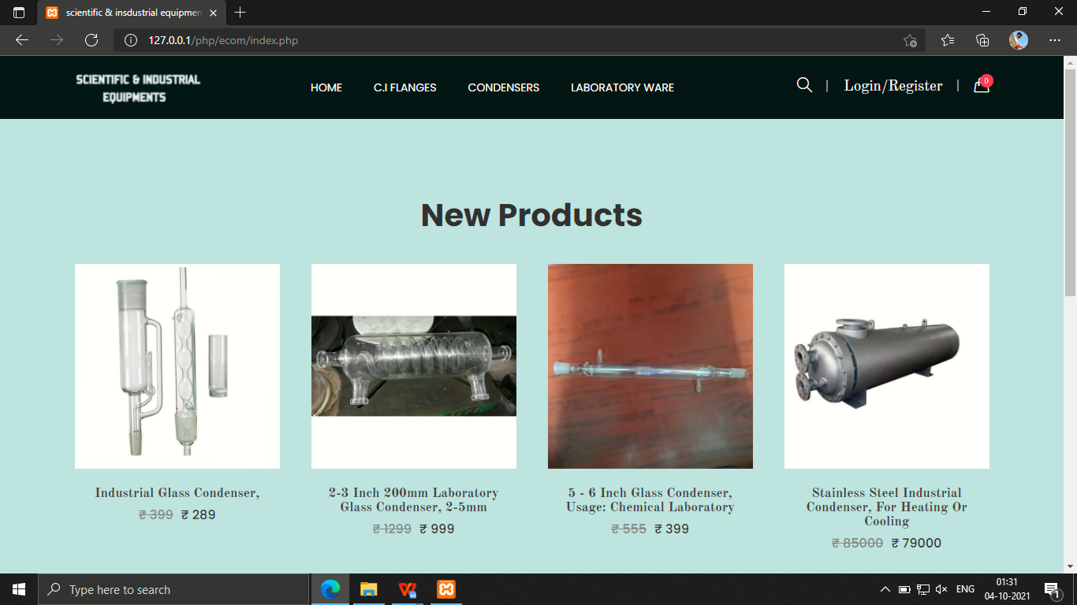

Login & Register page

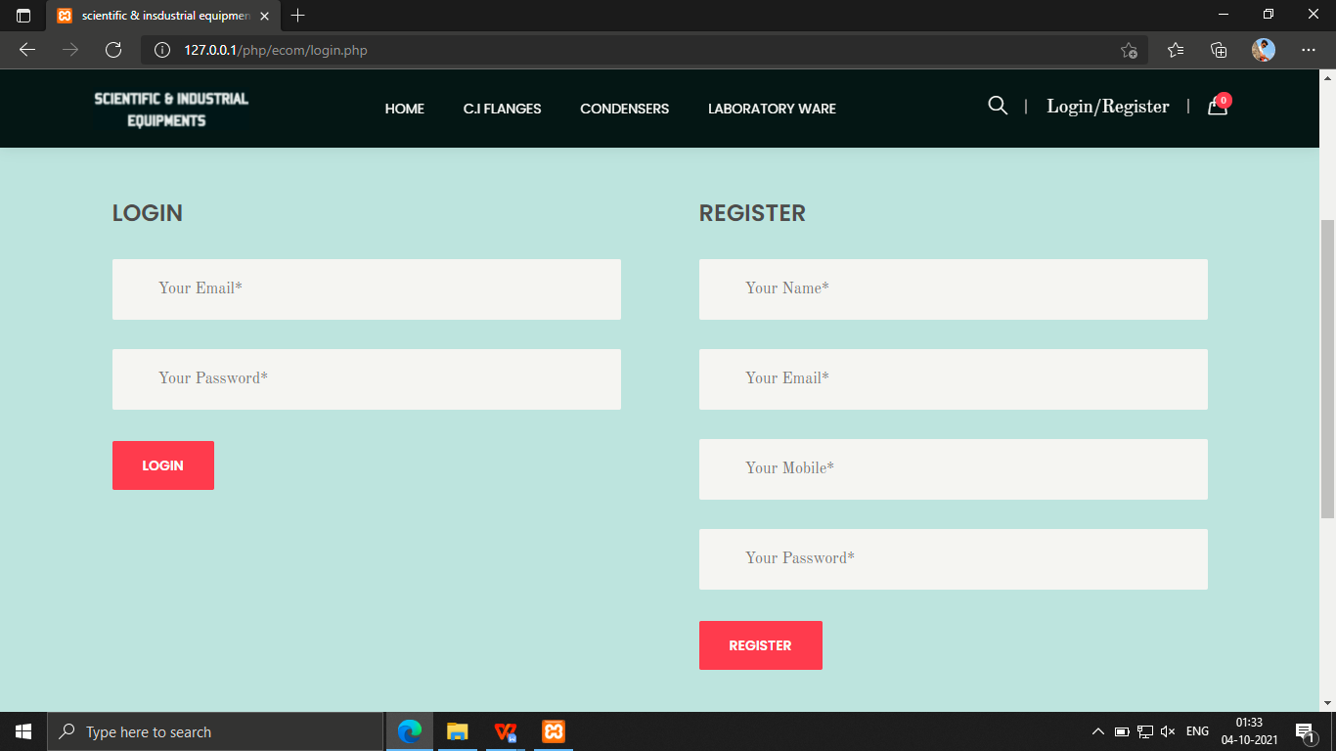

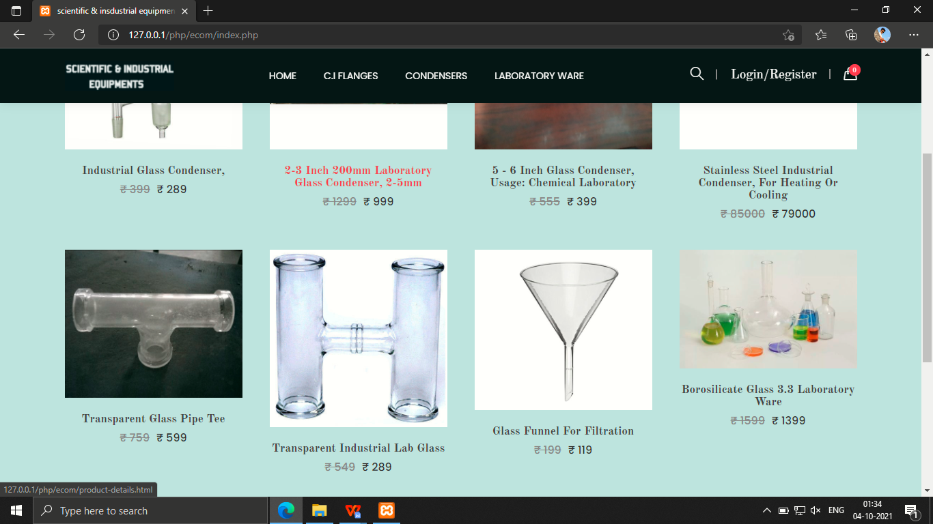

Product

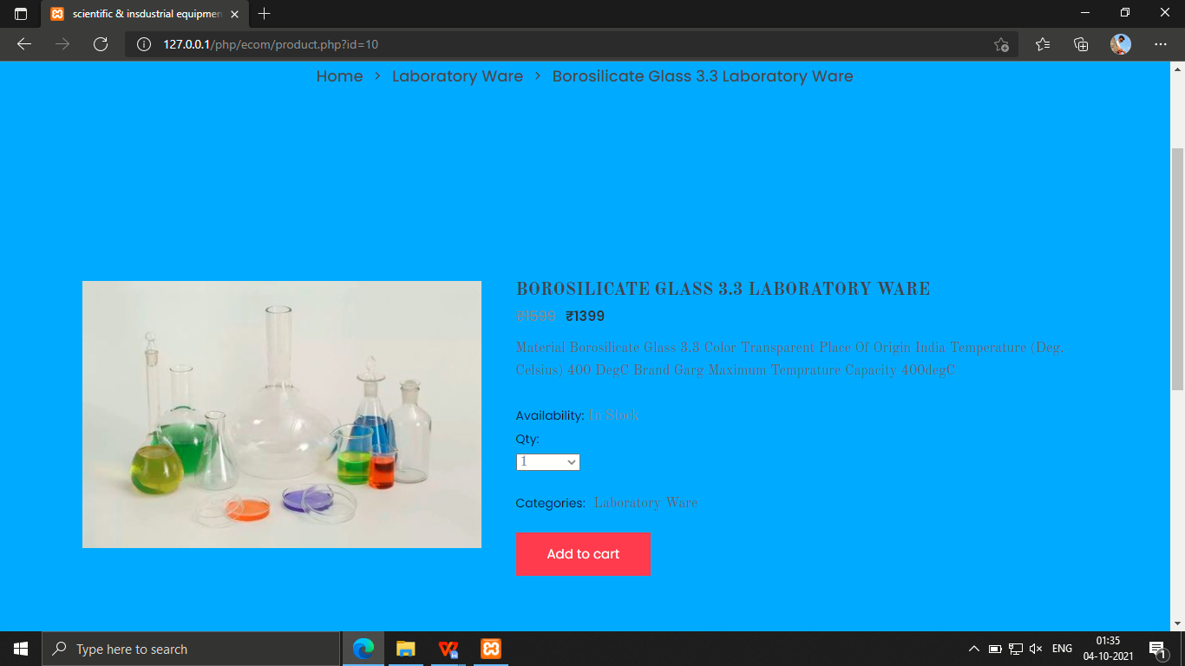

Cart
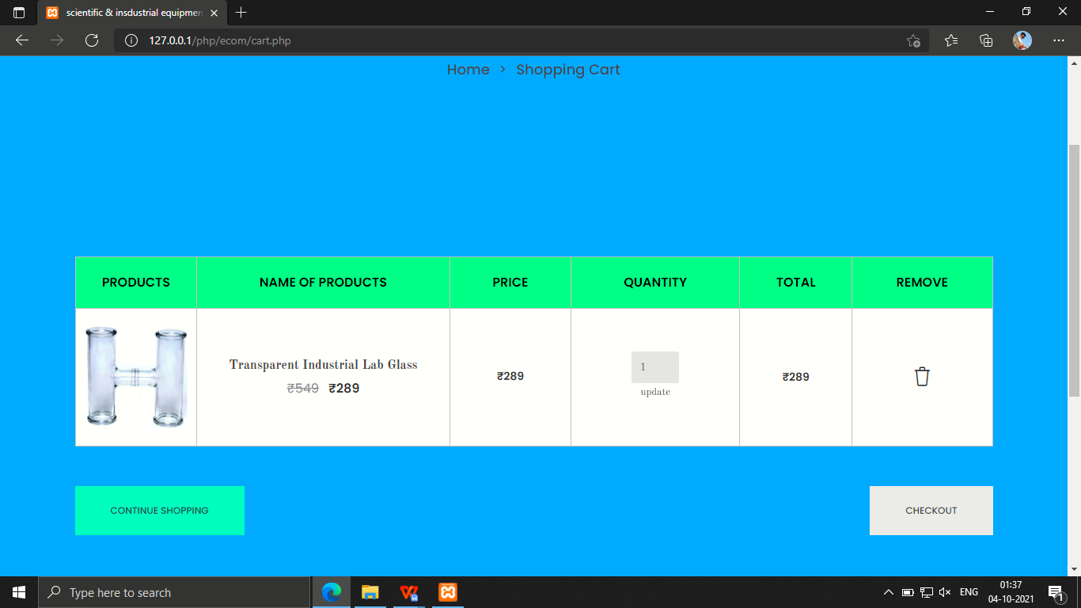

Checkout
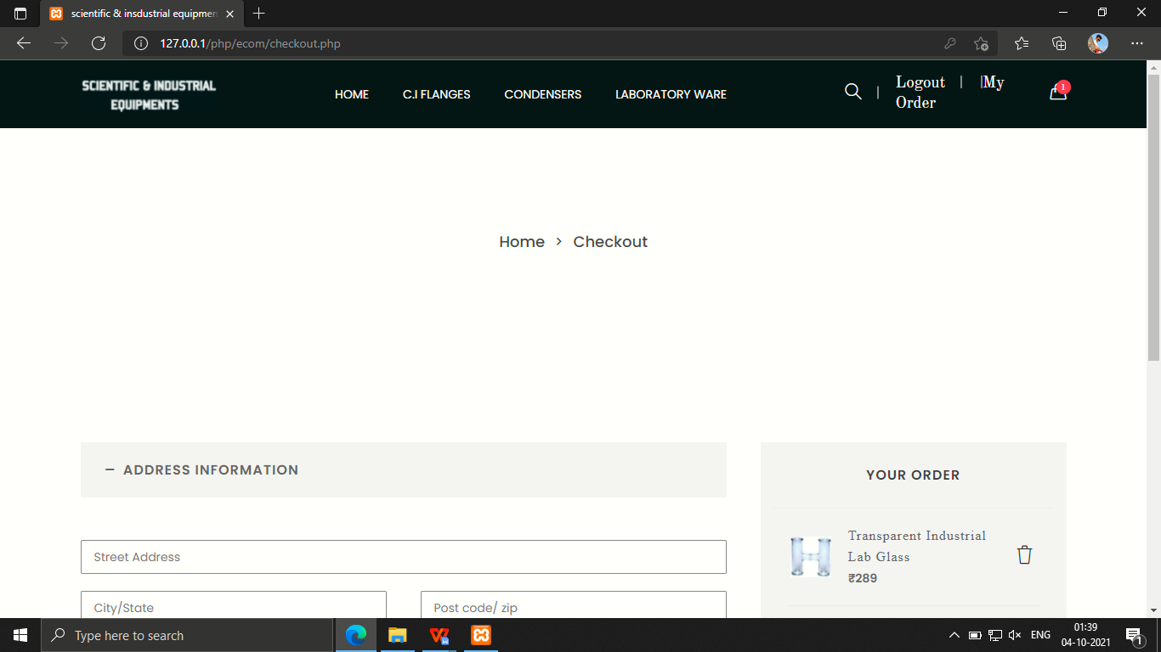

ADMIN PANEL
ADMIN LOGIN
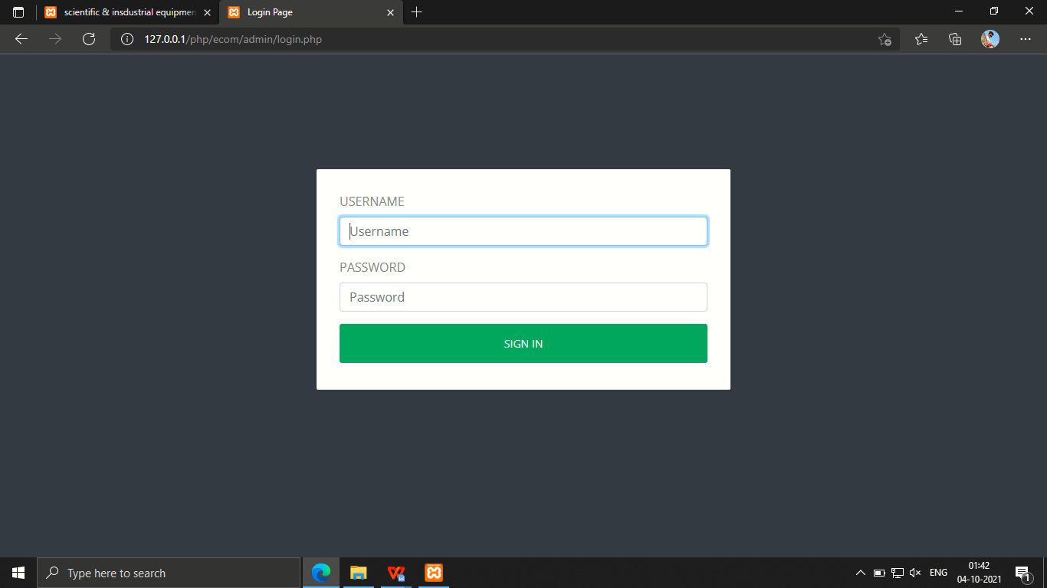

ADMIN DASHBOARD
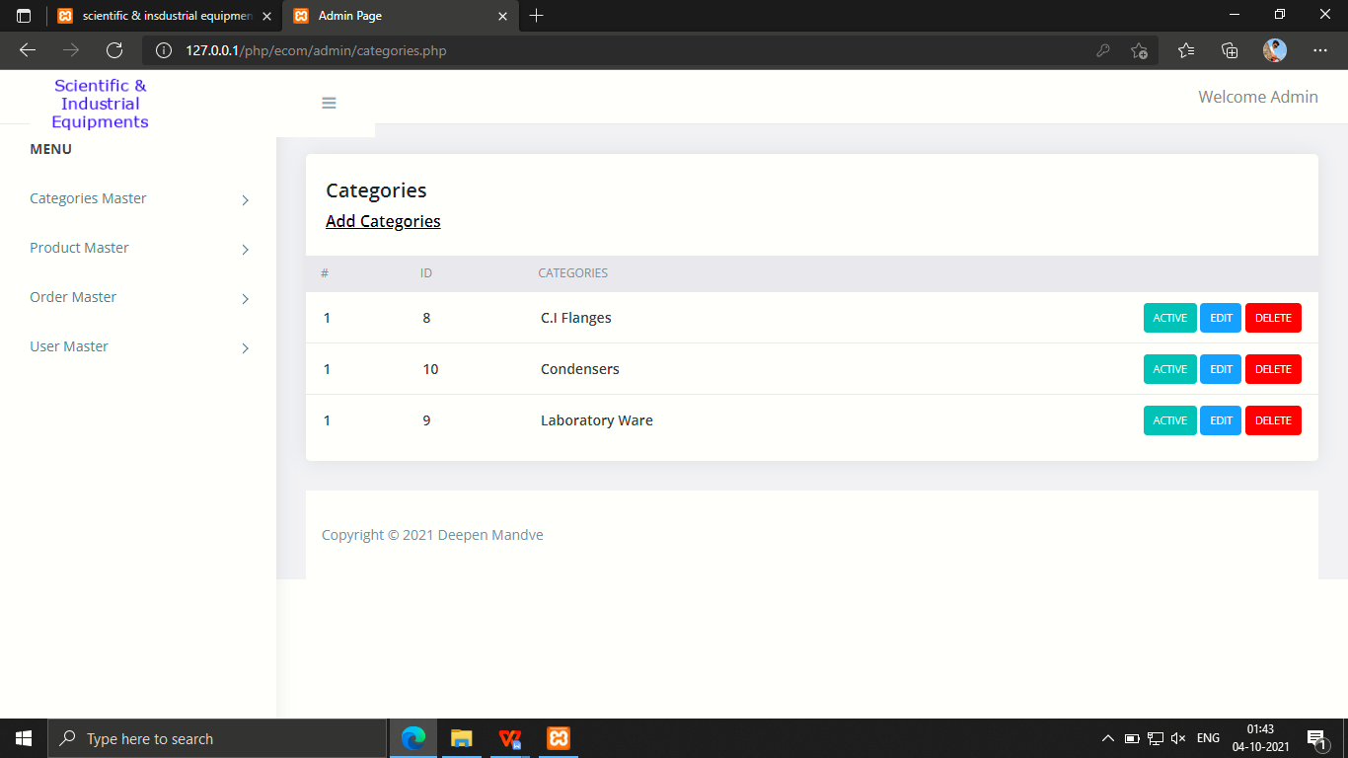
NEW CATEGORY
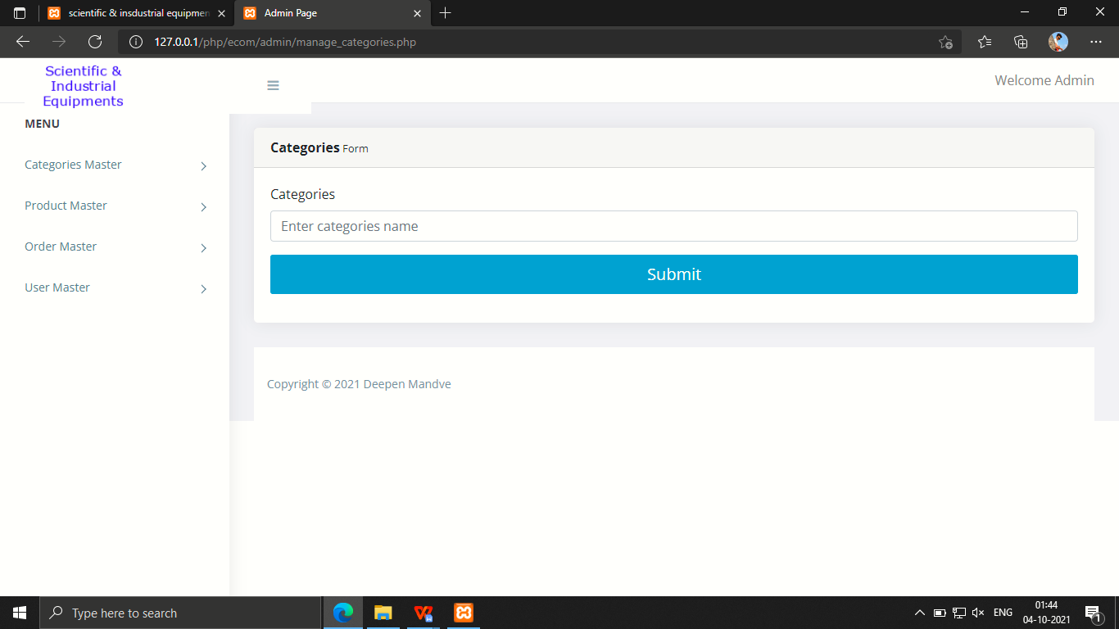

PRODUCTS
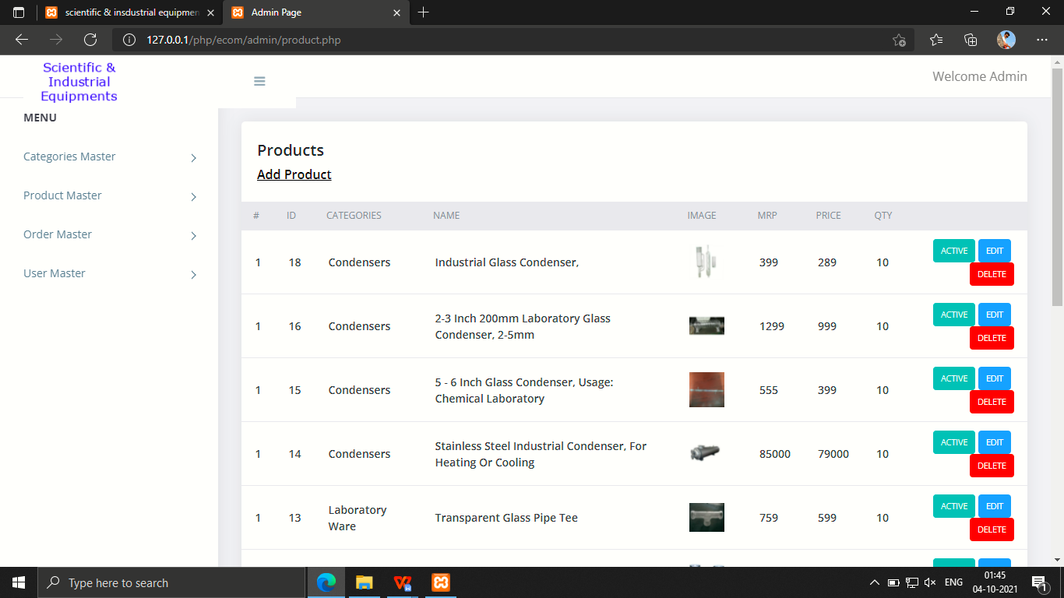

ADD PRODUCTS
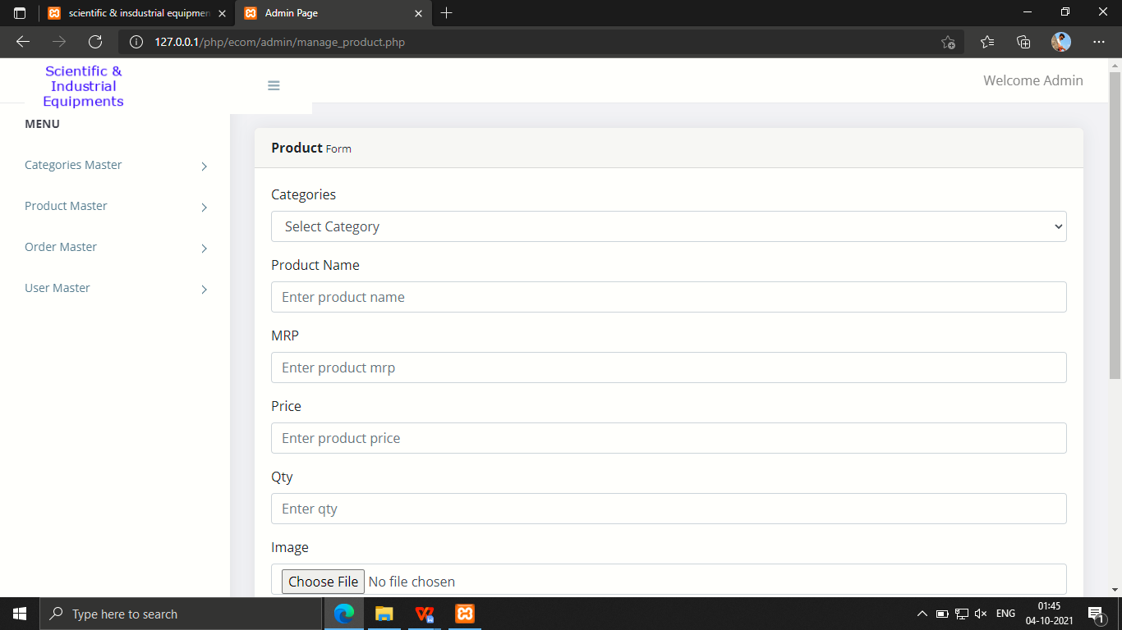

USER MANAGER
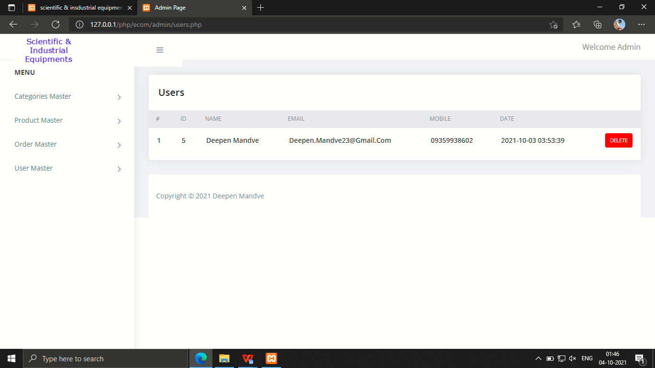
EDIT/UPDATE PRODUCT

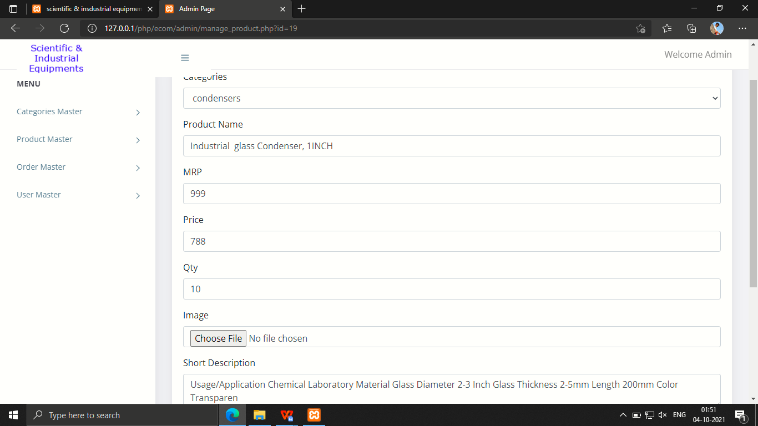
CONCLUSION AND FUTURE SCOPE

CONCLUSION:

The project Scientific & Industrial Equipments is completed, satisfying the required design specifications. The system provides a user-friendly interface. All modules in the system have been tested with valid data and invalid data and everything work successfully. Thus the system has fulfilled all the objectives identified and is able to replace the existing system. The constraints are met and overcome successfully.

FUTURE SCOPE:

This software has a user-friendly screen that enables the user to use without any inconvenience. The application has been tested with data and has provided a successful result. Hence the software has proved to work efficiently.

REFERENCES
The major source of Knowledge for this project are as follow
- https://stackoverflow.com
- https://www.w3schools.com/php/default.asp
- http://php.net/docs.php
- https://api.jquery.com
- https://getbootstrap.com
- https://youtube.com
- https://color-hex.com
- https://geeksforgeeks.org

